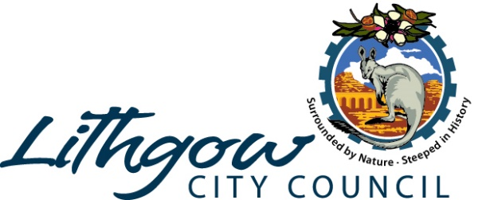

DETERMINATION AND STATEMENT OF REASONS
(Published pursuant to Clause 20 of Schedule 1 of the Environmental Planning and Assessment Act 1979)

Application No | DA145/20
Proposal: | SHED - BUSHFIRE AFFECTED
Address: | Lot 46 DP 237413 Vol 11067 Fol 00085  105 Kerma Crescent  CLARENCE NSW 2790
Determination | Determination
Approval Date: | 18/09/2020
Reasons for Decision: | The development adequately satisfies the applicable provisions and objectives of the Lithgow Local Environmental Plan 2014.  The development is consistent with relevant SEPP’s and Policies.  The proposed development, subject to the conditions imposed, will have no unacceptable adverse impacts on the natural or built environment including the quality of local water systems, the operation of the local road system or the amenity of residential premises in the locality due to noise, traffic, overshadowing or overlooking.  The proposed development is a suitable use of the site and approval is in the public interest.  Adjoining property owners were notified of the proposed development in accordance with Council’s policy and no submissions were received.

